COURSE: MLA02 - Fundamentals of Machine Learning Name: EKALAIVAN L
DATE: 28.10.2026 Reg.no: 192524450

EXPERIMENT 6: Write a Python program to implement the Naive Bayes algorithm and display the results using confusion matrix and accuracy
Aim
To write a Python program to implement the Naive Bayes algorithm and to display the results using a confusion matrix and accuracy.
Algorithm
Step 1: Start the program.
Step 2: Load the Iris data set and split it into training and testing sets.
Step 3: Create the Gaussian Naive Bayes classifier.
Step 4: Calculate the prior probability of each class and the mean and variance of each feature for every class from the training data.
Step 5: For each test sample, calculate the posterior probability of every class using Bayes theorem with the independence assumption.
Step 6: Assign the class with the highest posterior probability to the sample.
Step 7: Repeat Steps 4-6 for all the test samples.
Step 8: Display the confusion matrix and calculate the accuracy.
Step 9: Classify a new sample and display the predicted class.
Step 10: Stop the program.
Program:
from sklearn.datasets import load_iris
from sklearn.model_selection import train_test_split
from sklearn.naive_bayes import GaussianNB
from sklearn.metrics import confusion_matrix, accuracy_score

iris = load_iris()
X_train, X_test, y_train, y_test = train_test_split(
iris.data, iris.target, test_size=0.3, random_state=42)

model = GaussianNB()
model.fit(X_train, y_train)
y_pred = model.predict(X_test)

print("Confusion Matrix:")
print(confusion_matrix(y_test, y_pred))
print("Accuracy: %.2f%%" % (accuracy_score(y_test, y_pred) * 100))

sample = [[6.0, 2.9, 4.5, 1.5]]
print("\nNew sample:", sample[0])
print("Predicted class:", iris.target_names[model.predict(sample)[0]])
Output
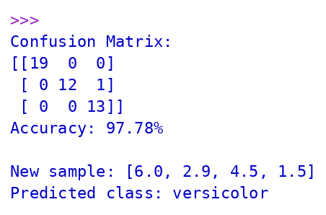
Result
The Naive Bayes algorithm was successfully implemented using Python, and the model classified the Iris test data with an accuracy of 97.78%, as shown by the confusion matrix.
EXPERIMENT 7: Write a Python program to implement the Logistic Regression algorithm
Aim
To write a Python program to implement the Logistic Regression algorithm.
Algorithm
Step 1: Start the program.
Step 2: Create the data set of hours studied and the result (Pass = 1, Fail = 0).
Step 3: Split the data into training and testing sets.
Step 4: Create the Logistic Regression model, which applies the sigmoid function to a linear combination of the input.
Step 5: Train the model using the training data to learn the coefficient and the intercept.
Step 6: Predict the class of the test data using a threshold of 0.5.
Step 7: Calculate the accuracy and display the confusion matrix.
Step 8: Predict the probability of passing for new values of hours studied.
Step 9: Display the results.
Step 10: Stop the program.
Program:
import numpy as np
from sklearn.linear_model import LogisticRegression
from sklearn.model_selection import train_test_split
from sklearn.metrics import accuracy_score, confusion_matrix

# Hours studied vs Pass (1) / Fail (0)
hours = np.array([0.5,0.75,1.0,1.25,1.5,1.75,2.0,2.25,2.5,2.75,3.0,3.25,3.5,4.0,4.25,4.5,4.75,5.0,5.5,6.0]).reshape(-1, 1)
passed = np.array([0,0,0,0,0,0,0,0,0,1,0,1,1,1,1,1,1,1,1,1])

X_train, X_test, y_train, y_test = train_test_split(
hours, passed, test_size=0.3, random_state=1, stratify=passed)

model = LogisticRegression()
model.fit(X_train, y_train)
y_pred = model.predict(X_test)

print("Coefficient :", round(model.coef_[0][0], 4))
print("Intercept :", round(model.intercept_[0], 4))
print("Accuracy :", accuracy_score(y_test, y_pred))
print("Confusion Matrix:\n", confusion_matrix(y_test, y_pred))

for h in [1.5, 3.0, 4.5]:
prob = model.predict_proba([[h]])[0][1]
print(f"Hours = {h}: P(Pass) = {prob:.3f} -> {'Pass' if prob >= 0.5 else 'Fail'}")
Output
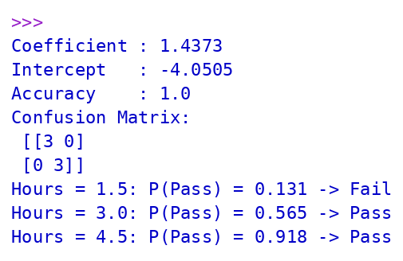
Result
The Logistic Regression algorithm was successfully implemented using Python, and the model predicted the pass or fail result along with the probability for the given hours studied.
EXPERIMENT 8: Write a Python program to implement the Linear Regression algorithm
Aim
To write a Python program to implement the Linear Regression algorithm.
Algorithm
Step 1: Start the program.
Step 2: Create the data set of hours studied (input) and marks scored (output).
Step 3: Split the data into training and testing sets.
Step 4: Create the Linear Regression model, y = m x + c.
Step 5: Train the model using the training data to find the slope (m) and the intercept (c) by the least squares method.
Step 6: Predict the output for the test data.
Step 7: Calculate the Mean Squared Error and the R2 score.
Step 8: Predict the marks for a new value of hours studied.
Step 9: Display the results.
Step 10: Stop the program.
Program:
import numpy as np
from sklearn.linear_model import LinearRegression
from sklearn.model_selection import train_test_split
from sklearn.metrics import mean_squared_error, r2_score

# Hours studied vs marks scored
hours = np.array([1.1,1.5,2.0,2.5,3.2,3.5,4.0,4.5,5.1,5.5,6.0,6.9,7.4,7.8,8.5,9.2]).reshape(-1, 1)
marks = np.array([17,20,27,30,35,31,41,47,52,60,56,70,68,78,82,90])

X_train, X_test, y_train, y_test = train_test_split(hours, marks, test_size=0.25, random_state=0)

model = LinearRegression()
model.fit(X_train, y_train)
y_pred = model.predict(X_test)

print("Slope (m) :", round(model.coef_[0], 4))
print("Intercept (c) :", round(model.intercept_, 4))
print("Mean Squared Error:", round(mean_squared_error(y_test, y_pred), 4))
print("R2 Score :", round(r2_score(y_test, y_pred), 4))
print("\nActual Predicted")
for a, p in zip(y_test, y_pred):
print(f"{a:5d} {p:8.2f}")
print("\nPredicted marks for 7.5 hours:", round(model.predict([[7.5]])[0], 2))
Output
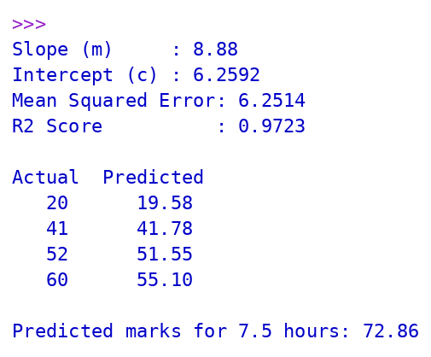
Result
The Linear Regression algorithm was successfully implemented using Python, and the model predicted the marks with an R2 score of 0.9723.
EXPERIMENT 9: Write a Python program to compare Linear and Polynomial Regression
Aim
To compare Linear Regression and Polynomial Regression using Python.
Algorithm
Step 1: Start the program.
Step 2: Create a non-linear data set of position level and salary.
Step 3: Fit a Linear Regression model to the data and calculate its Mean Squared Error and R2 score.
Step 4: Transform the input into polynomial features of degree 2, 3 and 4.
Step 5: Fit a Linear Regression model on each set of polynomial features.
Step 6: Calculate the Mean Squared Error and the R2 score for each polynomial model.
Step 7: Predict the salary for a new position level using the linear model and the polynomial model.
Step 8: Compare the results of the models.
Step 9: Stop the program.
Program:
import numpy as np
from sklearn.linear_model import LinearRegression
from sklearn.preprocessing import PolynomialFeatures
from sklearn.metrics import mean_squared_error, r2_score

# Non-linear data: position level vs salary (in thousands)
x = np.arange(1, 11).reshape(-1, 1)
y = np.array([45, 50, 60, 80, 110, 150, 200, 300, 500, 1000])

lin = LinearRegression().fit(x, y)
y_lin = lin.predict(x)
print("Linear Regression")
print(" MSE :", round(mean_squared_error(y, y_lin), 2))
print(" R2 :", round(r2_score(y, y_lin), 4))

for d in [2, 3, 4]:
poly = PolynomialFeatures(degree=d)
xp = poly.fit_transform(x)
model = LinearRegression().fit(xp, y)
yp = model.predict(xp)
print(f"Polynomial Regression (degree {d})")
print(" MSE :", round(mean_squared_error(y, yp), 2))
print(" R2 :", round(r2_score(y, yp), 4))

print("\nPrediction for level 6.5:")
print(" Linear :", round(lin.predict([[6.5]])[0], 2))
poly = PolynomialFeatures(degree=4)
m4 = LinearRegression().fit(poly.fit_transform(x), y)
print(" Polynomial :", round(m4.predict(poly.transform([[6.5]]))[0], 2))
Output
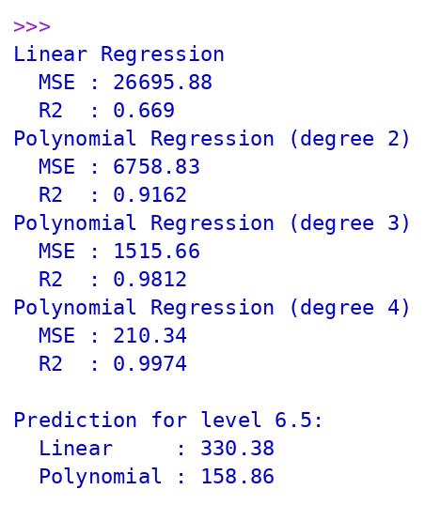
Result
Linear and Polynomial Regression were compared using Python. The polynomial model fitted the non-linear data much better (R2 = 0.9974 for degree 4) than the linear model (R2 = 0.669).
EXPERIMENT 10: Write a Python program to implement the Expectation and Maximization (EM) algorithm
Aim
To write a Python program to implement the Expectation and Maximization (EM) algorithm.
Algorithm
Step 1: Start the program.
Step 2: Generate the data from two Gaussian distributions.
Step 3: Initialize the means, variances and mixing weights of the two components.
Step 4: E-step: calculate the responsibility (probability of belonging to each component) of every data point using the current parameters.
Step 5: M-step: update the means, variances and mixing weights using the responsibilities.
Step 6: Repeat the E-step and M-step for a fixed number of iterations or until the parameters converge.
Step 7: Display the parameters at selected iterations.
Step 8: Display the final estimated parameters and compare them with the true parameters.
Step 9: Stop the program.
Program:
import numpy as np

np.random.seed(0)
# Data generated from two Gaussian clusters
data = np.concatenate([np.random.normal(2, 1.0, 150), np.random.normal(8, 1.5, 150)])

def gaussian(x, mu, var):
return np.exp(-(x - mu) ** 2 / (2 * var)) / np.sqrt(2 * np.pi * var)

# Initial guesses
mu = np.array([1.0, 6.0]); var = np.array([1.0, 1.0]); pi = np.array([0.5, 0.5])

for it in range(1, 31):
# E-step: responsibilities
r = np.array([pi[k] * gaussian(data, mu[k], var[k]) for k in range(2)])
r = r / r.sum(axis=0)
# M-step: update parameters
Nk = r.sum(axis=1)
mu = (r * data).sum(axis=1) / Nk
var = (r * (data - mu[:, None]) ** 2).sum(axis=1) / Nk
pi = Nk / len(data)
if it in (1, 5, 10, 20, 30):
print(f"Iteration {it:2d}: means = {np.round(mu, 3)}, variances = {np.round(var, 3)}, weights = {np.round(pi, 3)}")

print("\nFinal estimated parameters:")
for k in range(2):
print(f"Component {k+1}: mean = {mu[k]:.3f}, variance = {var[k]:.3f}, weight = {pi[k]:.3f}")
print("\nTrue parameters: means = [2, 8], variances = [1.0, 2.25], weights = [0.5, 0.5]")
Output
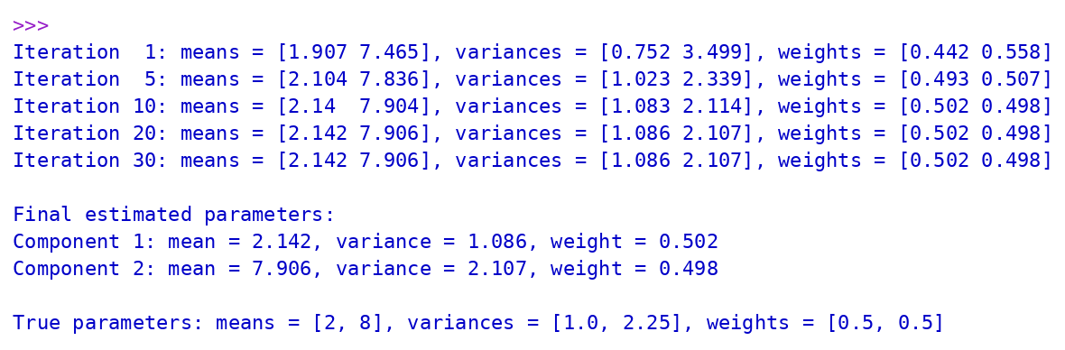
Result
The Expectation and Maximization algorithm was successfully implemented using Python, and the parameters of the two Gaussian components were estimated and converged close to the true values.

